INTRODUCTION

In the year 2006, 458,293 new registered vehicles were reported compared to the year 1999 where there were only 296,716 new registered vehicles, which makes it a rough estimate of 54.5% increase in a span of 7 years (Malaysian Ministry of Transportation, 2007). Referring to the aforesaid statistics provided by the Malaysian Ministry of Transportatioru the current transportation infrastructure and car park facilities are deemed insufficient in sustaining the influx of vehicles on the road.

Therefore, problems such as traffic congestion and insufficient parking space inevitably crops up. In Asia, the situation are made worse by the fact that the roads are significantly narrower compared to the West (Inaba et al., 2001). Various measures have been taken in the attempt to overcome the traffic problems. Although, the problem can be addressed via many methods, the paper focuses on the car park management system introduced, which is the smart parking system. This study will review the evolution of vehicle detection technologies as well as the detection systems developed over the years.

INTRODUCTION

In the 21st century finding a free car parking slot has become a mind-numbing process, especially for people who travel in the morning to work or are following their daily routine, they find it highly difficult and challenging to get a parking slot for their cars. Moreover, the parking slots are never user-friendly and provide no logical data about the availability of the spot unless the user visits it manually.

These kind of problems are faced regularly by every individual because the factor of uncertainty is very high and there are not many possible solutions in existence for solving the issue that may benefit the users by saving their time or keeping their mental state happy and carefree.

In our ever populating cities and districts to find parking space is becoming increasingly difficult as traffic increases. Drivers have to go back and forth desperately looking for parking spaces wasting their valuable time, fuel consumption with increased likelihood of causing accidents. With the help of wireless network technology we propose remote parking monitoring and automated guidance which will help save a lot of time.

In the existing system we can see that some supervision is required for the parking system and it not fully automated. The driver has to make sure that the car is parked in a spot without disturbing the convenience of others. In most cases the main problem is finding the spot and trying to secure the spot for parking which in turn leads to increased stress level for the person driving the car.

Moreover, the relative analysis of the data is structural to the implementation of the parking procedure.

Nowadays, in this busy world it’s really hard for a person to find a spot for parking. The current parking system doesn’t give the user a specified parking slot inside the area. Parking in general in a long and timeconsuming process and we hope to provide a solution to alleviate this problem

Abstract, traffic problems are bound to exist. This is due to the fact that the current transportation infrastructure and car park facility developed are unable to cope with the influx of vehicles on the road. To alleviate the aforementioned problems, the smart parking system has been developed. With the implementation of the smart parking system, patrons can easily locate and secure a vacant parkmg space at any car park deemed convenient to them. Vehicle ingress and egress are also made more convenient with the implementation of hassle free payment mechanism. With vehicle detection sensors aplenty on the market, the choices made may defer due to the different requirements in addition to the its pros and cons. Subsequently, the various sensor systems used in developing the systems in addition to the recent research and commercial system on the market are examined as vehicle detection plays a crucial role in the smart parking system.

Abstract-The main aim that we have is to create a completely automated car parking system with minimal human interference. With the rising population in the world, time is of the essence and hence we need to minimize the time taken by trivial activities such as finding a place to park in a busy place and avoid traffic congestion. We have seen in existing systems sometimes accidents can occur in parking situations by cars going at high speed o caused by frustrated drivers unable to find a parking space for a long period of time. In our project we propose a smart and automated car parking model that will help the user in booking their parking spaces beforehand and the vehicle will be able to park automatically once in the parking zone .The difference between our project of automated car parking systems is we hope to minimize human interaction as much as possible and make both the vehicle and the parking area fitted with sensors that will help us execute a safe and efficient way of parking. Hence, we aim to provide a completely safe and automated experience that is robust and can be implemented in real time and hopefully be implemented as the general norm for parking systems in the future. 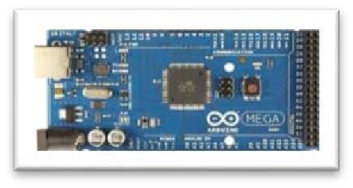

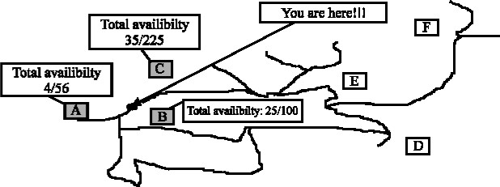

will

be

expired

within

30

min

researved

at

A.

Your

reservation